**Documentation for compare.py**

Yousuf Mohammed

December 5, 2019

**Dependencies**

The only dependency needs should be xlsxwriter which is used to manipulate excel files. It can be downloaded with pip

* Pip install xlsxwriter

**Documentation**

1. *create_workbook*

* Description
  + wrapper for the xlsxwriter workbook creation function so you don’t have to remember it every time.
* Inputs
  + name - string name of the excel file to be created
* Outputs
  + returns an xlsxwriter workbook for you to use in the other functions

1. *compare*

* Description
  + compare blobs using xlsxwriter and save in excel file
* Inputs
  + workbook - an xlsxwriter workbook which is used to write the information to excel files
  + caffetxt - string name of file where the caffe layer's output is stored
  + cpptxt - string name of file where the cpp layer's output is stored
  + caffeSheetName - string of desired name for the caffe sheet in the excel file. Useful for differentiating multiple layers in a single file. If nothing is provided will default to Sheet1, Sheet2, etc.
  + cppSheetName - string of desired name for the cpp sheet in the excel file. Useful for differentiating multiple layers in a single file. If nothing is provided will default to Sheet1, Sheet2, etc.
  + errorSheetName - string of desired name for the error sheet in the excel file. Useful for differentiating multiple layers in a single file. If nothing is provided will default to Sheet1, Sheet2, etc.
* Outputs
  + does not return anything, however the workbook provided is now filled populated with comparisons of the passed in information.

1. *auto_compare* **NOTE: HAS NOT BEEN TESTED**

* Description
  + compares all files in two directories assuming filenames for each layer are stored in their respective locations in the same order and creates an excel sheet showcasing the similarities
* Inputs
  + excelFileName - name of excel file to be created
  + caffe_path - path to directory holding files of caffe layer's outputs. Assumes there is a file in the directory named filenames.txt that contains a list of all other files in the directory in order.
  + cpp_path - path to directory holding files of cpp layer's outputs. Assumes there is a file in the directory named filenames.txt that contains a list of all other files in the directory in order.
* Outputs
  + does not return anything but creates an excel file that holds all the comparisons

1. *write_caffe_files*

* Description
  + takes a net after forward pass has occurred and writes the blobs, weights and biases to files. The weights and biases are saved as arrays in cpp format.
* Inputs
  + net - the caffe net that has all the information after a forward pass has taken place.
  + blobs_directory - directory to save blob files
  + weights_directory - directory to save weight files
  + bias_directory - directory to save bias files
  + dimensions - string, either '3d' or '2d' determines whether 4 dimensional weights will be saved as 2 dimensional arrays or one large 3-dimensional array
* Outputs
  + does not return anything but weights biases and blobs are stored in files in their respective directory.

1. *write_cpp_files*  **NOTE: HAS NOT BEEN IMPLEMENTED YET**

* does nothing.

**Usage**

1. Creating a workbook

* Use the create_workbook function.
* Note that in order to save a workbook in must be closed first.

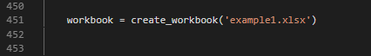

1. Compare two files

* Create a workbook.
* Call compare and pass it your workbook, the locations of the files and if desired the names of the sheets.

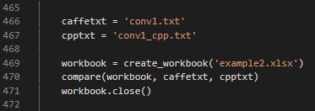

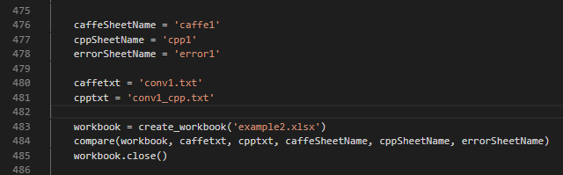

1. Generate files from caffe net

* First run your caffe net so it has appropriate blob data.
* Call write_caffe_files and pass it your net and the locations to save the files.



1. Closing a workbook

* Call workbook.close()

